Contents
Overview 1
Enable Applicant Email Contact Type for New Starter 1
View Contact Details within People Management 2
Contact Types Available 2
Contact Type Information 3

Overview

When an applicant is onboarded from the Recruitment module into People Management and becomes an employee the default Contact Type field for the applicant’s personal email to populate is ‘EMAIL – WORK’. A new parameter allows the organisation to select which ‘Contact Type’ field they wish to be populated as an alternative when a new starter (applicant) is pulled through, this does not rewrite when a later contract is appointed such as a new additional or transfer occurs.

Enable Applicant Email Contact Type for New Starter

Navigation via: Administrator Dashboard > Admin Settings

Enter the parameter code in the keyword field and press search.

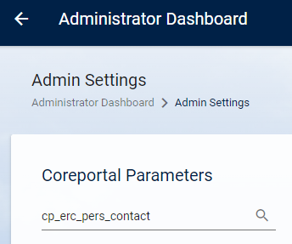

Parameter code is: cp_erc_pers_contact.
Parameter description is Applicant Email Contact Type for New Starter.

Click EDIT

An Edit Current Value popup is displayed, complete this with the relevant Contact Type Code you wish to be populated with the personal email address and click OK.

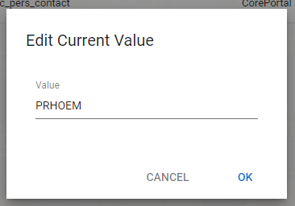

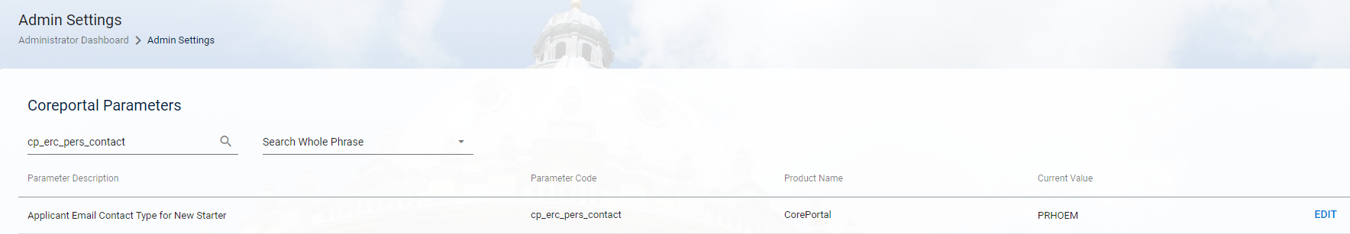

View Contact Details within People Management

The email address can be viewed against the employee record via:

People Management > Employee Search > ACTIONS > Personal Profile > Contact Details:

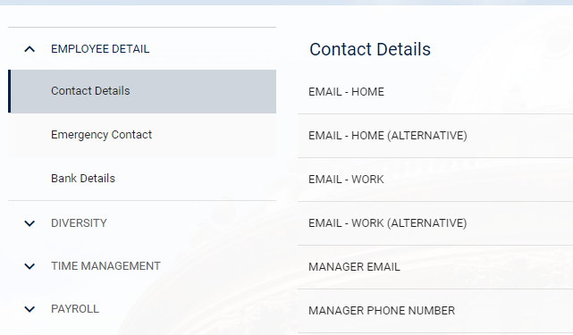

Contact Types Available

A full list of avaialble Contact Types can be found by navigating via:

People Management > Data Centre > Reference Data > Contact Type

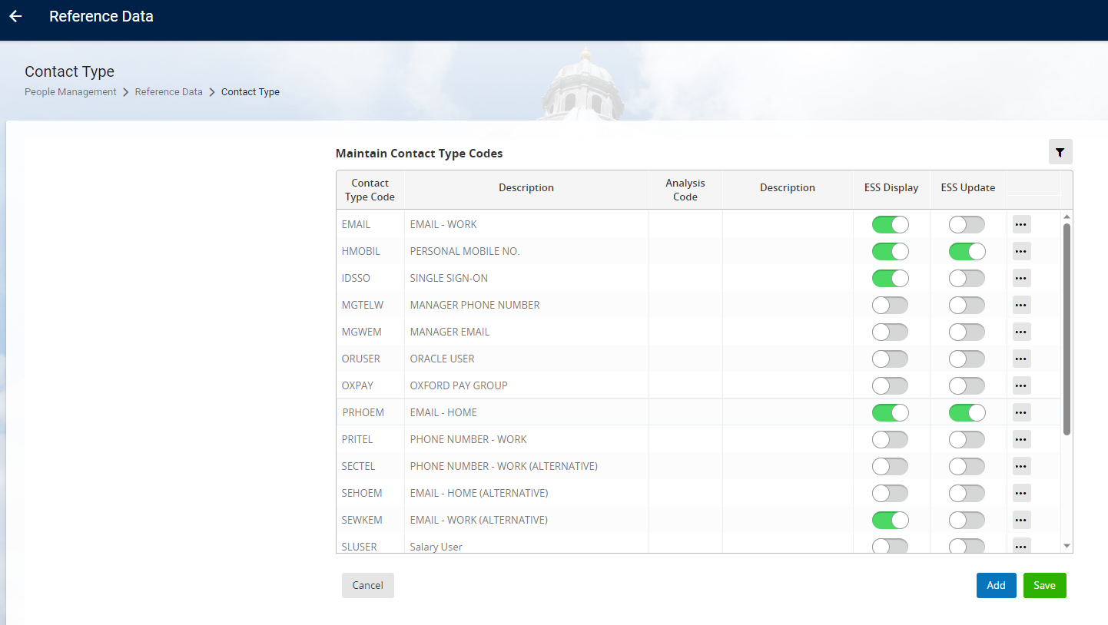

Contact Type Information

We have configured the applicants personal email address to be populated into the EMAIL-HOME field. The Contact Type Code for this is PRHOEM.

There is an overnight interface which brings in the employees University email address and populates this into the Contact Type field EMAIL-WORK. The Contact Type Code for this is EMAIL. This Contact Type fields should not be manually updated within People Management as the overnight interface will always overwrite the field.

